December 9, 2015

Dear Parents,

Re: Relocation of InSchoolwear

We are excited to announce that InSchoolwear will be moving to a new location as of December 18th, 2015. After months of searching we have found the perfect location to allow us to carry a larger amount of product and become even more efficient then we’ve ever been. We will now be able to offer extended hours to serve you better. Our new hours areTuesday, Wednesday, Friday and Saturday – 9:30 am to 5:30 pm and Thursday 9:30am until 7:00. Our new telephone number is (416) 423-3032.

Located under 10 km from our current location, our new store is very easy to find.

209 Wicksteed Avenue, Units 22, 23 and 24 M4G 0B1

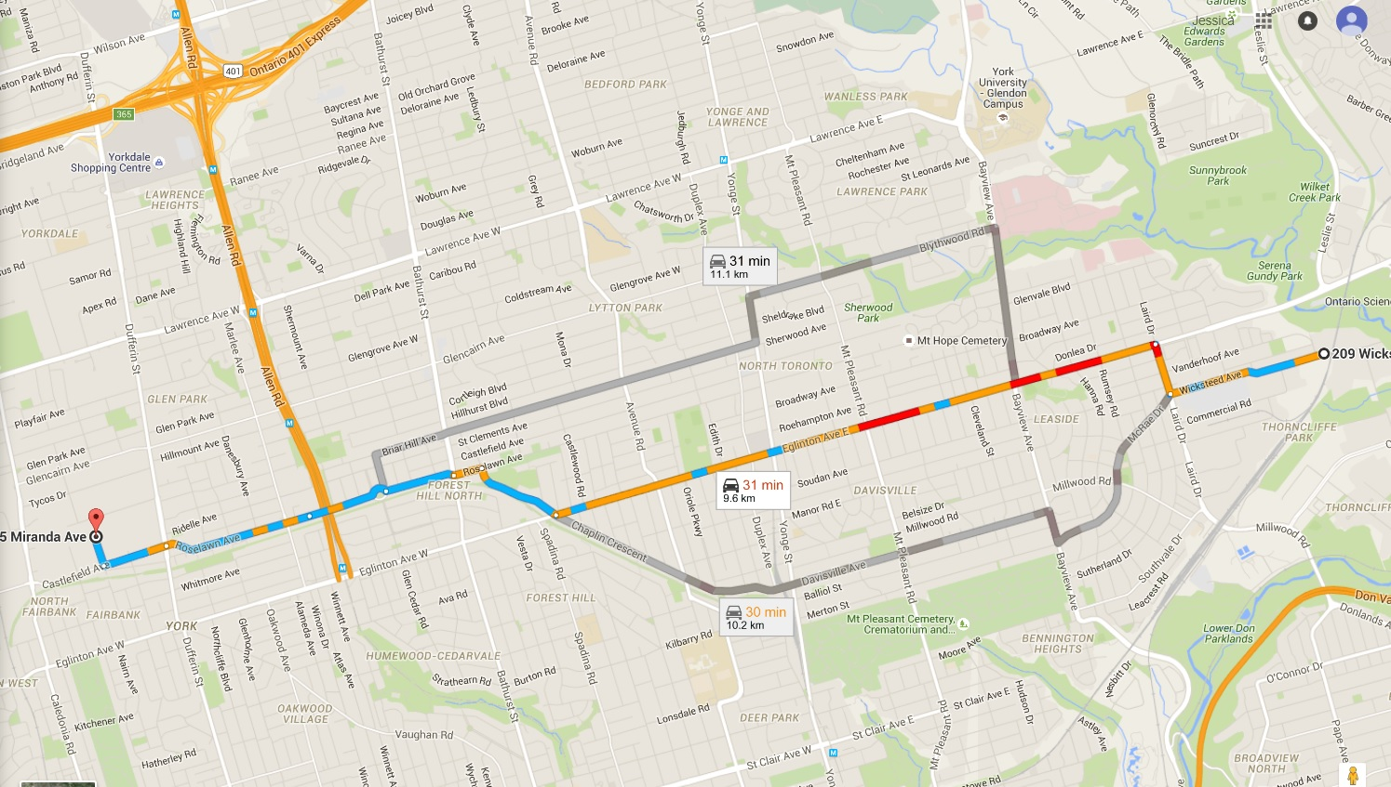

In order to facilitate this move, we will be closing on December 15th at 5:30 pm and reopening in our new location on December 18th at 9:30 am. We do apologize for our temporary closure but look forward to welcoming you in our new location.

Regards,

Amelia Gray

Store Manager

InSchoolwear